CS5590BD-Big data Analytics and Applications

Lab-02

Data Collection Apps based on App1 (Accelometer data) and App3 (GPS data)

HBase Client - CRUD (Create, read, update and delete) with HBase

By

Syamala Reddy Arimanda

16168332

Data Collection based on accelerometer data and GPS data from BLE sensor Tag and Android Mobile device

I’ve downloaded the zip folder given in the tutorial into the eclipse which consists of code.

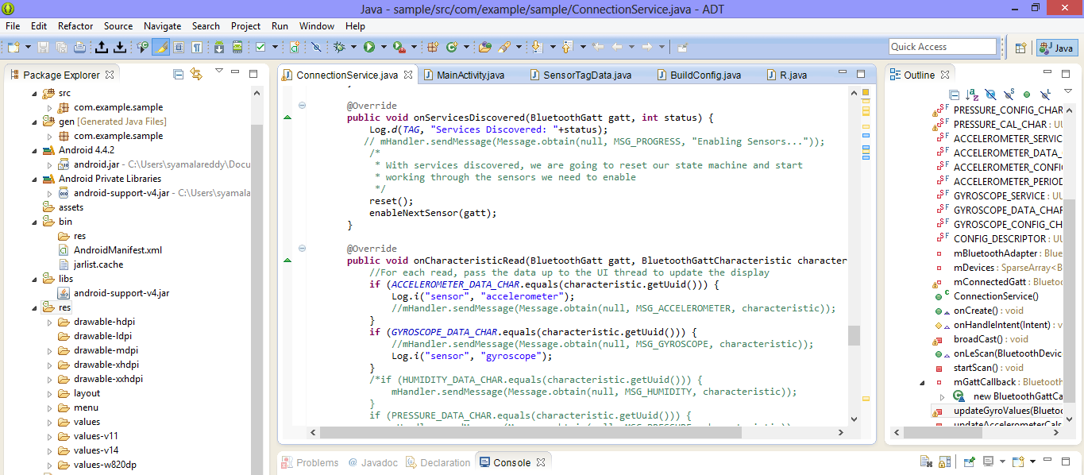

All my source files are attached in the github. I’ve developed the code to measure the values of temperature, pressure, humidity and gyroscope using the sensor tag services.

Then this program and the application in the android device which is imported into eclipse is run and the output for the code which shows accelometer, GPS, Humidity sensor enabled.

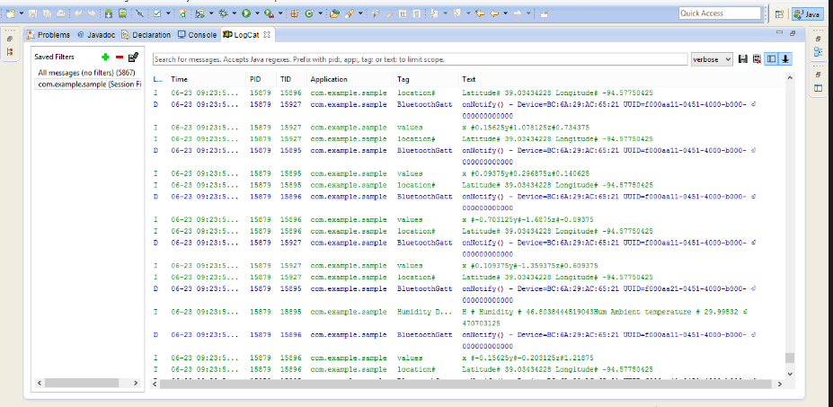

I’ve successfully coded and the humidity and temperature data along with the previous data services is successfully shown in the figure below.

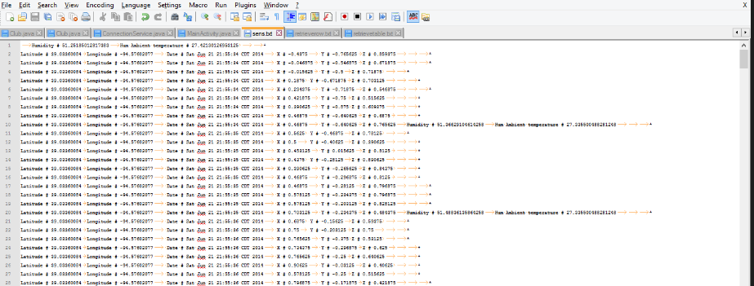

Uploading the data into HBase

I’ve developed the HBaseclient.java file and written my file and imported into HBase (cloudera manager). I had successfully created a HBase table of name Group1SensorTable, and insert data into that table.

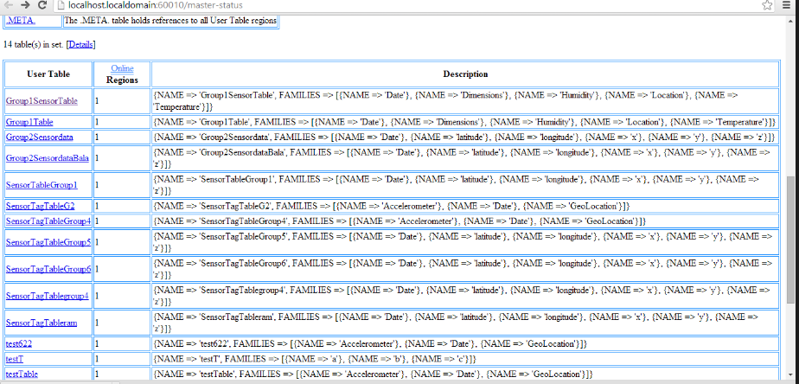

Using the command retrievetable( ) ,I’ve successfully retrieved the data entries.

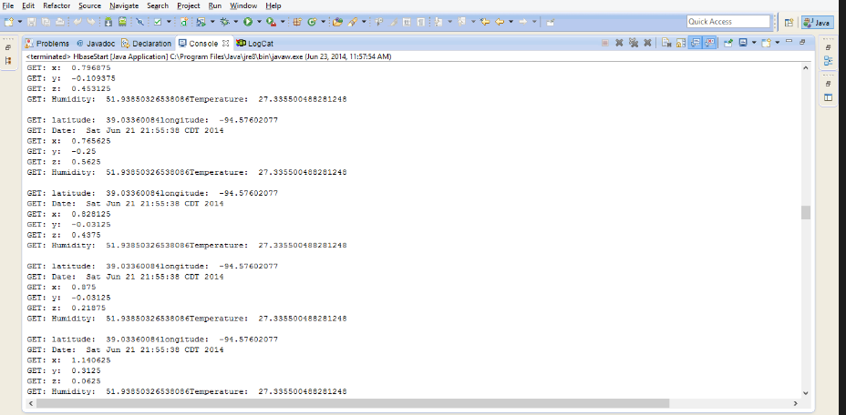

Using the command getallrow() the data has been successfully retrieved and using the command getalltable() the data is retrieved from all the row entries as shown below.

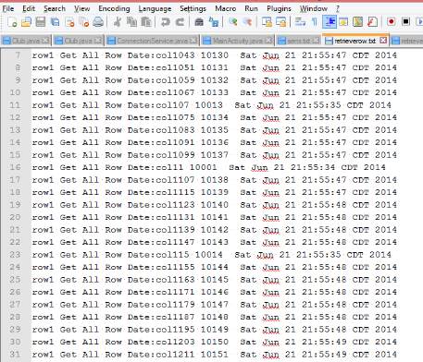

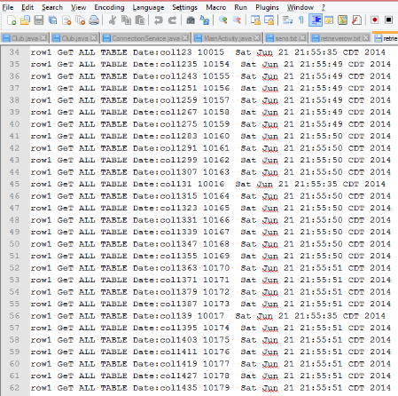

In this way the data is being Created, read, updated and deleted using HBase.